**DataWareHouse Architecture**:-

A data warehouse is a type of data management system that is designed to enable and support business intelligence (BI) activities, especially analytics. Data warehouses are solely intended to perform queries and analysis and often contain large amounts of historical data

**Working procedure of DWH :-**

There are several stages in this process.

**Extraction:-**

Extraction is the operation of extracting data from a source system for further use in a data warehouse environment. This is the first step of the ETL process. After the extraction, this data can be transformed and loaded into the data warehouse.

**Data Cleansing :-**

Data cleansing or data cleaning is the process of detecting and correcting (or removing) corrupt or inaccurate records from a record set, table, or database and refers to identifying incomplete, incorrect, inaccurate or irrelevant parts of the data and then replacing, modifying, or deleting the dirty or coarse data.

**Data Transformation :-**

Data transformation is the process of changing the format, structure, or values of data. ... Organizations that use on-premises data warehouses generally use an ETL (extract, transform, load) process, in which data transformation is the middle step.

**DATA UPLOADING :-**

Once all the data has been cleansed and transformed into a structure consistent with the data warehouse requirements, data is ready for loading into the data warehouse.  
The initial load of the data warehouse consists of populating the tables in the data warehouse schema and then checking that the data is ready for use.After the data has been loaded into the data warehouse database, verify the referential integrity between dimension and fact tables to ensure that all records relating to appropriate records in other tables. DBA should verify that every record in a fact table relates to a record in each dimension table that will be used with that fact table.  
  
Data integrity in the reverse order is not necessary, however, in some cases, it might be necessary to remove unrelated data. For example when a dimension table has several times more records than the fact table

**UPDATING DWH :-**

Do a refresh to view the cross verify the result on the dwh.

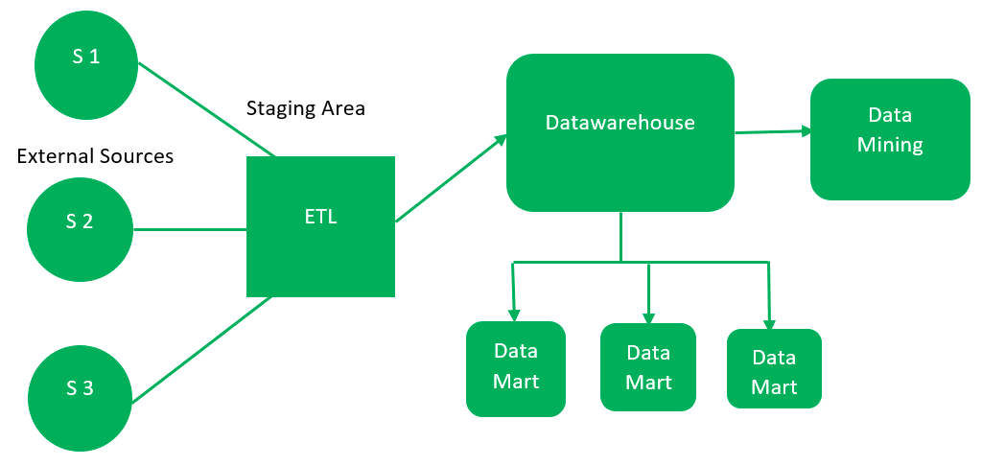 ***data warehouse architecture***

**Following are the top 8 Data Warehousing tools:**

* Amazon Redshift: Amazon Redshift is a cloud-based fully managed petabytes-scale data warehouse By the Amazon Company. ...
* Microsoft Azure
* Google BigQuery
* Snowflake
* Micro Focus Vertica
* Amazon DynamoDB
* PostgreSQL
* Amazon S3

Levels of data warehouse architectute :-

Bottom Tier :-

The bottom tier of the architecture is the data warehouse database server. It is the relational database system. We use the back end tools and utilities to feed data into the bottom tier. These back end tools and utilities perform the Extract, Clean, Load, and refresh functions.

Middle Tier :-

In the middle tier, we have the OLAP Server that can be implemented in either of the following ways.

* By Relational OLAP (ROLAP), which is an extended relational database management system. The ROLAP maps the operations on multidimensional data to standard relational operations.
* By Multidimensional OLAP (MOLAP) model, which directly implements the multidimensional data and operations.

Top Tier :- This tier is the front-end client layer. This layer holds the query tools and reporting tools, analysis tools and data mining tools.

What is DataCube :-

A data cube refers is a three-dimensional (3D) (or higher) range of values that are generally used to explain the time sequence of an image's data. ... Data cubes are used to represent data that is too complex to be described by a table of columns and rows.

Data Mining :-

Data mining is the process of understanding data through cleaning raw data, finding patterns, creating models, and testing those models. It includes statistics, machine learning, and database systems

Data Modeling & Types :-

 There are mainly three different types of data models: conceptual data models, logical data models, and physical data models, and each one has a specific purpose. The data models are used to represent the data and how it is stored in the database and to set the relationship between data items.